PNT2022TMID49260

12 NOVEMBER 2022

DATE

TEAM ID

|  |  |
| --- | --- |
| DATE | 19 NOVEMBER 2023 |
| TEAM ID | PNT2022TMID26841 |
| PROJECT NAME | HAZARDOUS AREA MONITORING FOR INDUSTRIAL PLANT POWERED BY IoT |

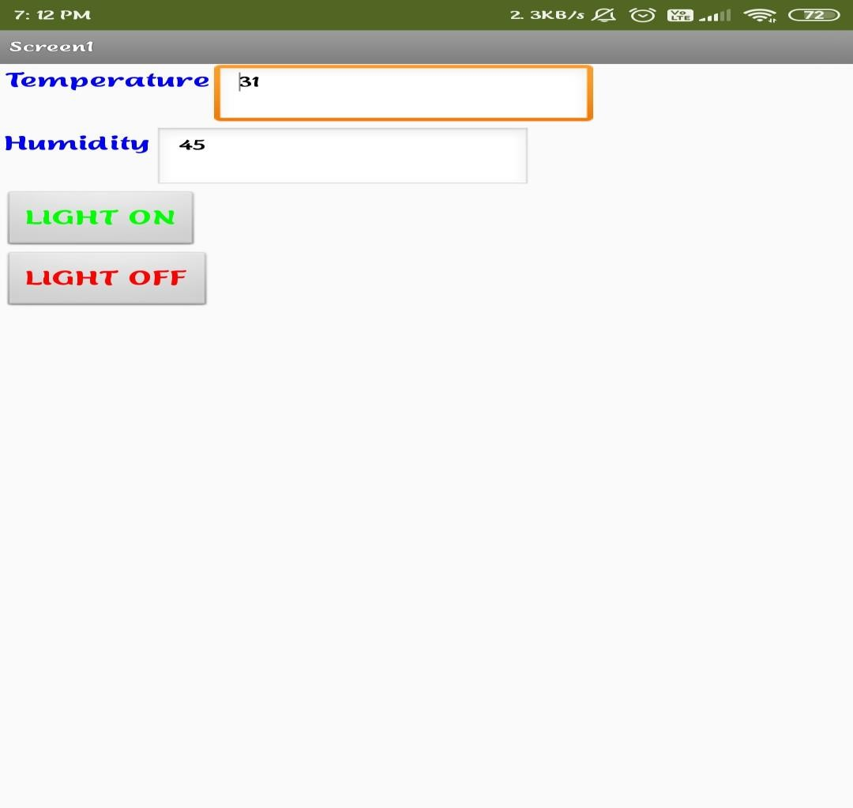Configure the mobile app for controlling motor using button:

PROJECT NAME

HAZARDOUS AREA MONITORING FOR

INDUSTRIAL PLANT POWERED BY IOT

Configure the mobile app for controlling motor using button creating successfully